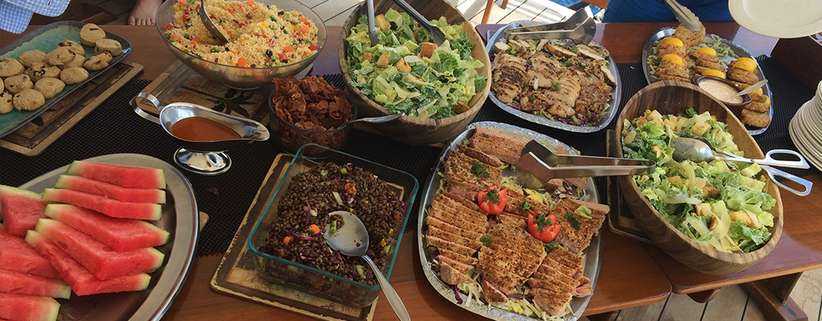

DINING on Cuan Law
Dining aboard the dive liveaboard Cuan Law- our chefs are extremely educated culinary masters and offer a wide variety of cuisines for our guests to enjoy. They know that scuba divers work up a large appetite. You’ll do more than fuel your scuba tummies with these delectable dishes! This is just a small sample of their offerings as they are constantly adding to their talents.

Sunday
Breakfast: French Omelet w/ Pepper Bacon & Warm Cinnamon Buns
Lunch: Korean BBQ Ribs w/ Pumpkin Coconut Soup, Cambodian Coleslaw, Fresh Fruit & White Chocolate Chip Cookies
Appetizer: Chicken Wings w/ Garlic Tahini Marinade
Dinner: Roast Duck Breast w/ Orange Tamarind Glaze, Shitake Mushroom Risotto, Roasted Carrots & Parsnips Dessert: Crispy Apple Tart w/ Vanilla

Monday
Breakfast: Egg & Bacon Breakfast Burritos w/ Blueberry Muffins
Lunch: Chicken & Vegetable Pot Pies w/Frisee Salad & Lemon Bars
Appetizer: Steamed Mussels w/ Creme Fraiche
Dinner: Crispy Sesame Salmon w/ Cucumber Salad, Coconut Rice & Sautéed Snow Peas

Tuesday
Breakfast: Banana Pancakes w/ Toasted Pecans & Maple Syrup
Lunch: Carne Asada & Al Pastor Tacos w/ Black Beans, Spanish Rice, Fresh Fruit Platter & Banana Drop Cookies
Appetizer: Smoked Trout Dip w/ Crostini
Dinner: Steak Au Poivre w/ Oven Roasted Tomato, Sautéed Zucchini & Mushroom, Baked Russet Potato.
Dessert: Chocolate Decadence Cake w/ Raspberry Coulis

Wednesday
Lunch: Selection of Cold Cuts and Cured Meats served with a freshly baked Grape and Fennel Bread, Roasted Pumpkin Soup, Garden Salad with assorted dressings, 3 Bean Salad, Cheese platter, Fresh Fruit and Cookies
Appetizer: Crab Cakes w/ Sweet Chili Sauce
Dinner: Chicken Breast Stuffed w/ Artichoke hearts, Pesto & Swiss Cheese Drizzled w/ Olive Oil & Balsamic Vinegar, Whipped Sweet Potato, Sautéed Red Peppers & Haricot Verts
Dessert: Sticky Date Pudding Cake w/ Local Rum Sauce

Thursday
Breakfast: Baked Croissants Stuffed w/ Ham, Scrambled Eggs & Provolone Cheese
Lunch: Kung Pao Chicken & 5-Spice Beef w/ Broccoli, Steamed Jasmine Rice, Homemade Spring Rolls, Green Salad, Fruit Platter & Coconut Macaroons
Appetizer: Homemade Pizzas
Dinner: Seared Yellowfin Tuna w/ Wasabi Aioli, Stir Fried Asian Vegetables & Coriander Turmeric Rice
Dessert: Banoffe Pie

Friday
Breakfast: Eggs Benedict w/ Hollandaise Sauce and Fresh Baked Banana Bread
Lunch: Beach BBQ on Virgin Gorda w/ Creole Chicken, Steamed Red Snapper, Cheeseburgers, Assorted Salads, Chips, Fresh Fruit & Oatmeal Cookies
Appetizer: Grilled Skewered Cajun Prawns w/Andoulli Sausage

Saturday
Breakfast: Pina Colada French Toast, Apple Sage Sausage & Maple Syrup
Dinner: Herb Crusted Pork Tenderloin w/ Potato Leek Dauphinoise & Steamed Broccoli
Dessert: Poached Pears w/ Caramel Sauce

